University of Washington

iSchool Info 330

# Module 01 Assignment - Database Design

In this module's assignment, you will learn about databases; why they exist, what types are common, and how they are created.

Here is the basic outline of this assignment and my estimated number of minutes to complete each component. You will have to adjust these numbers to fit your learning style, but they should help you plan your schedule.

1. Assignment Videos < 120 min

* Paper-Based Systems -15
* Creating Databases -1
* Relational Database Management Systems -14
* Creating Tables - 8
* Normalization - 36
* What is DBO - 2

2. Examples < 60 min

* SQL Intro - 5
* SQL Syntax - 5
* SQL Select - 5
* SQL Create DB - 5
* SQL Drop DB - 5
* SQL Create Table - 5
* SQL Drop Table - 5
* SQL Alter Table - 5

3. Reading < 120 min

* Introduction To DBs - 2
* What Is a Database? - 5
* History of Databases - 10
* The Relational Database - 10
* Fundamental Database Concepts - 10
* Other Types of Databases - 20
* Other Important Database Concepts - 20
* Commercial RDBMS Systems - 5
* Conclusion - 5

4. Documenting < 120 min

* Write a one-page paper on database basics - 90

5. Assignment Task < 120 min

* Assignment - How would you make a DB from an Invoice? - 90

# Assignment Videos

Please watch the following Videos:

* [Need for Databases Organize or Die](https://www.youtube.com/watch?v=HaJI7WQRGAY)
* [Paper-Based Systems](https://www.youtube.com/watch?v=xBWizCJP0JU)
* [Relational Database Management Systems](https://youtu.be/0BiFRWeH1kI)
* [Creating Tables](https://youtu.be/GaVQ52GJU64)
* [Normalization](https://youtu.be/-o5_D4BWbAk)
* [What is DBO](https://youtu.be/EGVOvdNyG9I)
* [Metadata Spreadsheets](https://youtu.be/angniIotJW4)

# Assignment Examples

Read and try out some SQL statements on the W3Schools website. This website has short articles about many subjects and we will use this site throughout the course. In many of these articles you will find a "Try it Yourself" section where you can experiment with the SQL language interactively.

This website will become one of your most used "Go To" sites as you progress in your learning. So please check out the following pages this week!

* [SQL HOME](https://www.w3schools.com/sql/default.asp)
* [SQL Intro](https://www.w3schools.com/sql/sql_intro.asp)
* [SQL Syntax](https://www.w3schools.com/sql/sql_syntax.asp)
* [SQL Select](https://www.w3schools.com/sql/sql_select.asp)
* [SQL Create DB](https://www.w3schools.com/sql/sql_create_db.asp)
* [SQL Drop DB](https://www.w3schools.com/sql/sql_drop_db.asp)
* [SQL Create Table](https://www.w3schools.com/sql/sql_create_table.asp)
* [SQL Drop Table](https://www.w3schools.com/sql/sql_drop_table.asp)
* [SQL Alter Table](https://www.w3schools.com/sql/sql_alter.asp)

# Assignment Reading

Since the course does not have an official text you will use various websites for your studies. This is a great way to learn new subjects and practicing it will be something you will use for years to come!

Please read the following web pages:

<https://www.techopedia.com/6/28832/enterprise/databases/introduction-to-databases> (external site)

**Introduction to Databases** By [Dixon Kimani](https://www.techopedia.com/contributors/dixon-kimani)

# Assignment Document

Write a one-page document that articulates the answer to the following questions. Use at least one well-formed paragraph per question. Using only a few short sentences is fine, but they must make sense and be well formed. (Please use save file as a .doc or .docx file)

1. Explain the purpose of a database and give an example of one you deal with in your life.
2. Explain the benefits of the Relational database design when compared to paper based system.
3. Discuss the purpose and benefits of following the normalization process during database design.
4. Explain the meaning behind the phrase "The Key, The Whole Key, and Nothing but The Key."
5. Explain the purpose of associative entities and provide an example.

***Important:*** *Your document must look professional to get full points! Use my example template and video, in the General Files and Topics module, as a guide for what I expect a professional paper to look like. Make sure you format it like a college paper instead of the text message. Things like your name, date, class, citations, introductory and summary paragraphs are always expected! Not putting these in the document you will cost you!*

# Assignment Task

I would like you to reflect on what you have learned in this module. To do so, you will write a SQL Script that creates a database called Assignment01DB_YourNameHere. Design your database tables to hold the data shown here:

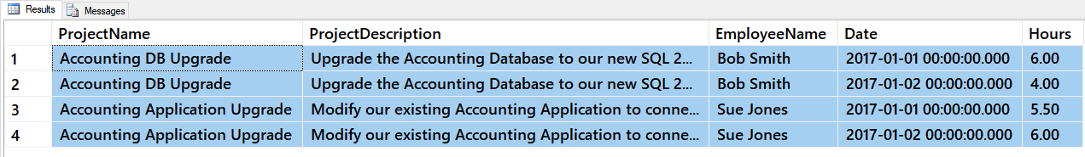

Figure 1: The data of the Assignment01DB_YourNameHere database

The data is not normalized so, you will need to re-organize it into a normalized design and then create your tables accordingly.

## Steps to take

I recommend you use the following steps to perform this task:

1. Review the data
2. Identify normalization issues
3. Create an ERD
4. Create the database script

### Notes:

* You will find code for creating databases and tables in your module's Module01Code-Normalization.sql file
* You do not have to create any Constraints in the database other than the Primary Keys
* You do not need to import the data into the database, you a working SQL Script

Make sure you place a developer header at the top of your script, you include the questions, and your SQL code. Your final script should look like this one:

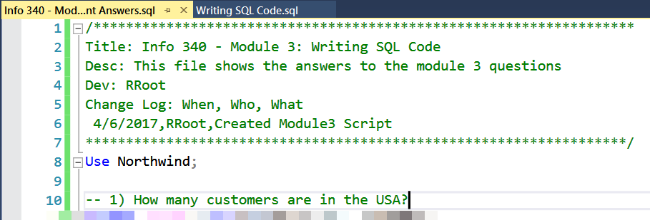

Figure 2: A Script Header

**Note**: Not putting your name, course, and date at the top of the document you will cost your 25% of your grade.

# Grading

Student work will be evaluated on a point system using the following general guidelines found on the Course Syllabus page. Make sure you read and understand this.

**NOTE:**  It is very possible to get a 3.9 or better from this course, but you have to earn it! Do not expect to get 100% of the possible points without extra effort on your part. If you want to excel in this course, you must submit **excellent**work!

# Submit your work

After you have completed your Word document and SQL Script, place both into a folder called Assignment01_**FirstInitialLastName** and Zip the folder.

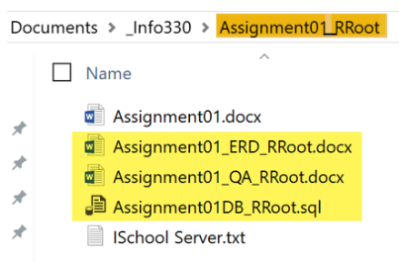

Figure 3: The assignment folder and files you need to turn in.

Upload the Zipped folder to the Canvas web site.

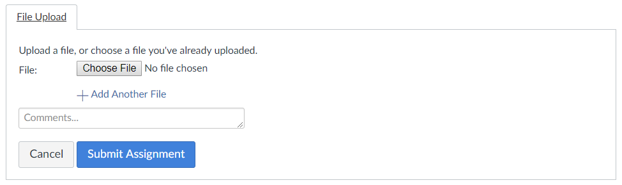

Figure 4: Typical buttons used to turn in an assignment on Canvas.